Rafts

What is a Raft?
A raft is a technique used to prevent warping. Parts are built on top of a 'raft' of disposable material instead of directly on the build surface. The raft is larger than the part and so has more adhesion. A raft is rarely used with heated build surfaces.

Why use a Raft?
A raft is typically used to achieve better build quality in parts that are printed on non-heated surfaces. A raft helps to ensure that the first few layers of a print are printed correctly. Since the first few layers can dictate how an overall print may turn out, it is important that the first few layers are printed correctly so that the final part will be printed correctly.

When not to use a Raft?
If the printer that is being used has a heated printing surface, then a raft is not needed. A heated print surface enables a filament to stick better to the print bed and therefore does not need the aid of a raft to ensure the first few layers are printed correctly. For non-heated build spaces, a raft may not be needed if the part being printed is small and simple in design. For example, if you are printing a name tag, which is both small and simple, a raft will not be necessary to ensure a good print.

How to remove of a Raft?
Once a print is finished, the part and raft are removed as one and the raft is snapped off of the part. In some cases, the raft may need to be cut off of the part.

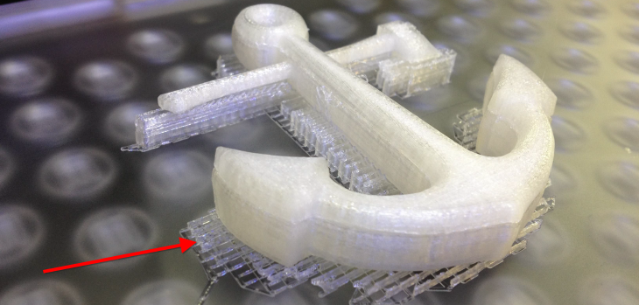

Courtesy of America Makes, the National Additive Manufacturing Innovation Institute, Youngstown, OH

